PSEUDOCODE MCQ
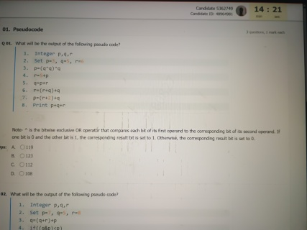
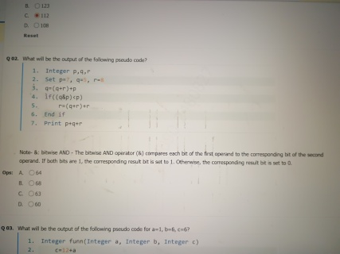
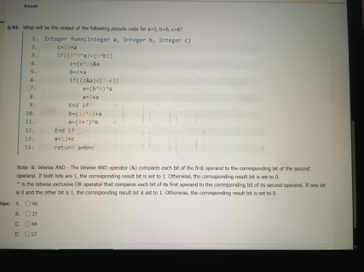

IMAGES MCQ
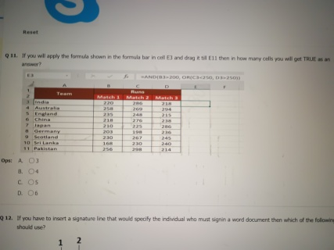
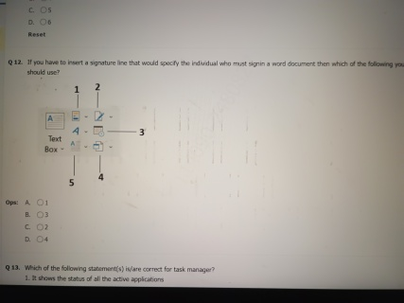

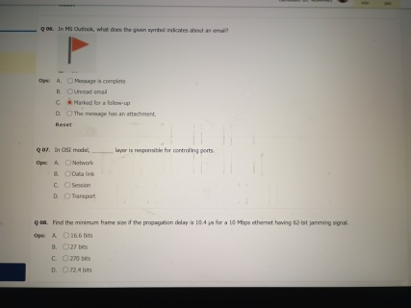
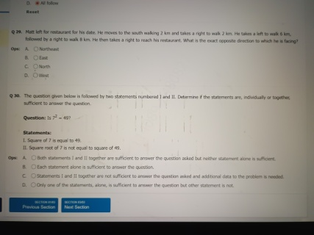
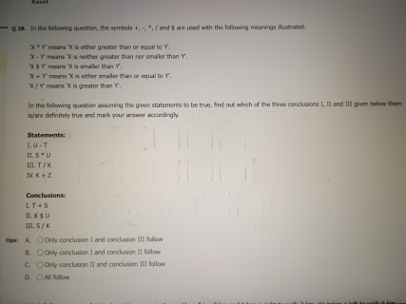
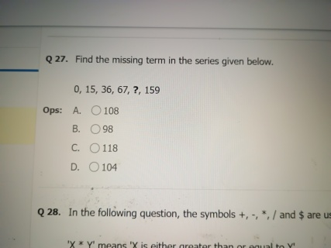

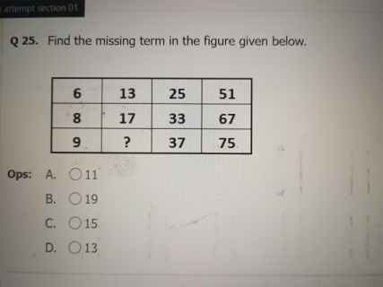
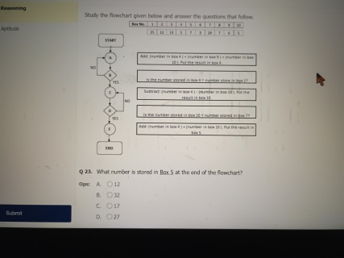
Q 24. How many times (in total) you will get a NO for the conditions given in step B and D?

Ops:

- 1
- 2
- 3
- 4

MCQ

Q01. Fill in the blank with an appropriate option in the given sentence:
The taxi driver returned the extra change back to the passenger.

Ops:
- clear
- faithful
- golden
- honest

Q 02. Fill in the blank with the most suitable option.
to play with the puppy. I am

Ops:
- treating
- excited
- exhausted
- innocent

Q 03. Fill in the blank with the most suitable option:

on the project for the last 7 days. I

Ops:

- working
- have been working
- was worked
- am worked

04. Fill in the blank with the most suitable option:
The blog good information on history.

Ops:
- to be containing
- is contained
- contains
- has been containing

Read the passage given below and answer the questions that follow.

High above the city, on a tall column, stood the statue of the happy prince. He was gilded all over with thin leaves of fine gold, for eyes he had two bright sapphires, and a large red ruby glowed on his sword-hilt.
He was very much admired indeed. "He is as beautiful as a weathercock," remarked one of the town councillors who wished to gain a reputation for having artistic tastes; "only not quite so useful," he added, fearing lest people should think him unpractical, which he really was not
"Why can't you be like the happy prince?" asked a sensible mother of her little boy who was crying for the moon. "The happy prince never dreams of crying for anything."
"I am glad there is someone in the world who is quite happy," muttered a disappointed man as he gazed at the wonderful statue.
"He looks just like an angel," said the Charity Children as they came out of the cathedral in their bright scarlet cloaks and their clean white pinafores.
"How do you know?" said the Math teacher, "you have never seen one."
"Ah! but we have, in our dreams," answered the children; and the Math teacher frowned and looked very severe, for he did not approve of children dreaming.

Q05. The passage is primarily concerned with:
Ops:
A. Analysing why the prince was happy
B. Analysing why people like statues
C. Describing people's attitudes about a statue
D. Describing how a statue looked

Q06. Which of these is true about the town councillor?

Ops:

- All of the mentioned options
- He was responsible for making the statue
- He wanted to be appreciated for his art
- He wanted to appear practical

Q 07. What does the word "gilded" mean in the context of the passage?

Ops:

- Covered
- Built
- Joined
- Broken

Many things can be consumed in small amounts and not cause serious harm. Fruit stickers are one of those things. They can be eaten, but they aren't exactly edible and neither is the adhesive used to stick them on. Fruit stickers and the adhesive only has to be proven as not deadly or extremely harmful to be put on an edible item. The FDA considers fruit stickers an "indirect food additive" and they must follow the guidelines for a "food contact substance."
However, the FDA regulations about this (like most things) are quite vague. This means that different companies can produce and sell the fruit stickers. Each sticker could be made from different papers and stuck on with a variety of different adhesives. None of which are actually edible.
Are any fruit stickers edible? Not really. While most of them can be eaten without causing serious harm, fruit stickers are not edible and should not be eaten. They should be removed and thrown away even though that just to the excessive trash problem we have. Some people have acknowledged not only that fruit stickers are not edible and dangerous but also that they are not needed.

Q08. Which of the following options best fits the blank given in the passage?

Ops:

- contributes
- associates
- patronises
- increases

Q09. The passage is primarily concerned with:

Ops:

- Discussing the safety of eating food stickers
- Analysing the utility of FDA rules
- Analysing the contents of stickers
- Discussing the safety of eating food with stickers

Choose the option that is closest in meaning to the word "vague" as used in the passage.

Ops:

- unhelpful

- possessive
- dangerous
- ugly

02. Analytical Reasoning

Read the passage given below carefully and answer the questions that follow.

A, B, C, D, E and F are 6 friends. Each one of them either always speaks the truth or always lies or alternatively speaks the truth and lies. They

make the following statements:

A: B is a liar
B: C is a liar
C: D is a liar
D: E is a liar
E: F is a liar
F: A is a liar

Q 21. If B is a liar and D is a truth teller then how many are surely liars?

Ops:
- 4
- 3
- 2
- 1

Q 22. Given that there are 2 truth tellers, 2 liars, 2 alternators, F is an alternator and B is a liar then D is a?
Ops:
- Either Liar or Truth Teller
- Alternator
- Liar
- Truth Teller

Q13. Mark the option which is closest to the meaning of the word given below.
RUMINATE

Ops:

- Inspire
- Ask
- Offer
- Meditate

Q 14. Mark the option which is closest to the meaning of the word given below.
ABSTAIN

Ops:
- Demand
- Obtain
- Avoid
- Give

11. The sentences given below form a coherent passage when arranged logically. Choose the option which gives the correct sequence.

(1) We had just started seeing a marriage counsellor, who believed such heated conversations were good to air out feelings.
(2) The argument stopped dead, and we huddled close as I grabbed a cricket bat to whip any intruders with.
(3) My wife and I were arguing, probably about something entirely silly because I can't remember what it is.
(4) Just as we were getting round to walking out of the room, we heard the window shatter.
(5) Turns out there was none, just a ball from the park nearby, but that incident showed to us how we trusted each other in our hearts.

Ops:
- 31452
- 31425
- 13452
- 13425

Q 12. The sentences given below form a coherent passage when arranged logically. Choose the option which gives the correct sequence.

1. The chopper is scheduled to depart from the hangar in three hours.
2. This has caused Rita to be worried about the other schedules being affected
3. Rita is calling for substitute engineers.
4. However, the test engineers haven't arrived yet.

Ops:
- 1423
- 4123
- 2314
- 03124

26. If in a certain code language, "MONARCH" is coded as "PQQCUEK", then how would "VENTURE" be coded in the same code language?

Ops:
- YGQVXTH
- YGOQXTH
- YGQVXSH
- YGOVTXH

Q 31. Find the area of a triangle whose sides are 50 m, 78 m, 112 m.

Ops:
- A.1240 m²
- B. 1080 m²
- C. 1520 m²
- D. 1680 m²

Q32. Lincoln can complete a task in 12 days; Joshua can complete it in 18 days. Chris can complete the same task in 24 days. Chris started the task. After 4 days, Lincoln and Joshua joined. If the task is completed in x more days, then find the value of x.

Ops:
- 62/13
- 61/17
- 58/17
- 60/13

Q 33. Jordan is running at a speed of 2 m/s. There is a bus stop of length 10 m at a distance of 80 m from Jordan. What is the time required by him to pass by the bus stop?

Ops:
- 19 seconds
- 24 seconds
- 34 seconds
- 45 seconds

Q05. Which of the following information is correct for SRAM?

- It stores static data in memory
- It remains active even after there is no power supply
- Same sized SRAM chip holds less data than DRAM

Ops:
- Only 1 & 3
- Only 2 & 3
- All 1, 2 & 3
- Only 1 & 2

Q13. Which of the following statement(s) is/are correct for task manager?

- It shows the status of all the active applications
- It shows the app usage history
- It can refresh the all the active apps.

Ops:
- Only 1 & 2
- Only 1 & 3
- All 1, 2 & 3
- Only 2 & 3

Q 14. is a collection of rules implemented for searching, retrieving and displaying documents from isolated sites.

Ops:
- Hyper Text Transfer Protocol Secure
- Telnet
- Gopher
- File Transfer Protocol

Q 15. In Gmail, if you have to tag an email as urgent then you should be a -
I. Sender
II. Receiver

Ops:
- Only II
- Only I
- Both I and II
- Neither 1 nor II

CODING
01. Number and its Reverse

Problem Statement

You are given two integers a and b representing the digits of a number. Your task is to find and print the difference between the number ab and its reverse ba.
Difference = ((10* a) + b) -((10 * b) + a)
Input Format:
- The Input consists of a single line:
- The line contains two integers a and b
- The input will be read from the STDIN by the candidate

Output Format:
Print the difference between the number ab and its reverse ba.
The output will be matched to the candidate's output printed on the STDOUT

Constraints:
- 1 ≤ a ≤ 9.
- 1≤ b≤9.

Example:
Input:
8 2

Output:
5 4

Explanation:
Difference = ((10*a) + b) ((10*b) + a) = ((10*8) + 2) - ((10*2)+8)=82-28 54. Thus, output is 54

Sample input
5 7

Sample Output
-18

Answer:
a, b = map(int, input().split())
print((10 * a + b) - (10 * b + a))

2. Merry Substrings of a string

Problem Statement
A string is called a "merry string" if the frequency of each letter in that string is 1
You are provided with a string S of length N. Find and print the number of merry substrings of length four that can be formed from the given string. If no such string is found then print '0'

Input format:
- The input consists of two lines.
- The first line contains N which represents the length of the string S.
- The second line contains the string S.
- Input will be read from the STDIN by the candidate.

Output Format:

- Find and print the number of merry substrings of length four that can be formed from the given string. If no such string is found then print '0'
- Output will be matched to the candidate's output printed on the STDOUT.

Constraints:

4 ≤ N ≤ 10^4

The input string should only consist of lower case English alphabets.

Example:
Input:
9
abcdefggh

Output:
4

Explanation:
There are 4 merry substrings
"abcd", "bcde", "cdef", "defg".
"efgg" and "fggh" are not merry because they have repeated characters.

Sample input
7
baninao

Sample Output
2

Answer:
n = int(input())
s = input().strip()

count = 0
for i in range(n - 3):
if len(set(s[i:i+4])) == 4:
count += 1

print(count)

